**f. 16r**

¶ca*pitulu*m 15•

n*ota* pylg*rym* •

|| [a]

**f. 16v**

*#

By*shop* of ly*n*co*n*e

**f. 17r**

*

•vol

n*ota*

• xiii •

13

**f. 17v**

**f. 18r**

¶ca*pitulum* 16 •

dyscresio*n*

**f. 18v**

**f. 19r**

no*ta*

¶ca*pitulum* 17•

[vyk*er*]

O>

¶

**f. 19v**

[loue]

passyon •

[brigytts

of •R• ha*m*pall

^

**f. 20r**

n*ota* [ferve*n*t loue

fader[?]

no*ta*

vii ȝere

O

**f. 20v**

goyd whyte

frere;

n*ota*

¶

¶ca*pitulum* 18•

­

**f. 21r**

dame Jelia*n*

[goyd co*n*sel •]

vigiles vi

e dess?

•

¶

**f. 21v**

¶

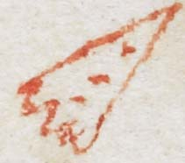

**f. 22r**

brokyn

bak ma*n*

**f. 22v**

¶

letter /

-------

**f. 23r**

n*ota*

lof

| •

ters w*yth*

loue •

ca*pitulum* 19•

**f. 23v**

¶ca*pitulum* 20

B ¶

**f. 24r**

¶ca*pitulum* 21

n*ota*

¶

O>

**f. 24v**

no*ta*

loue

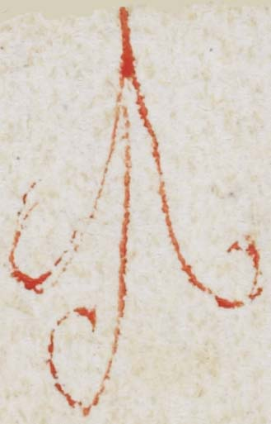 [and thy]

------------

¶

**f. 25r**

¶ca*pitulum* 22

n*ota*

no*ta*

tot*us*

¶

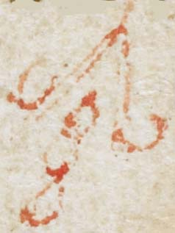

**f. 25v**

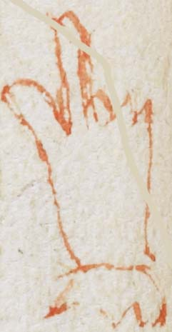

? shalben

?

for

¶

[unreadable]

[no*taˆ*

**f. 26r**

n*ota*

[si*n*gularis • c*risti* •

amatrix :~]

no*ta*

¶ca*pitulum* 23

n*ota*----|

|

|

|

|

**f. 26v**

n*ota*

¶

Ih*esu* •

¶

¶

¶

**f. 27r**

n*ota*

no*ta*

¶ca*pitulum* 24

^of thos thy*n*g*y*s

<

¶

**f. 27v**

**f. 28r**

n*ota*

**f. 28v**

¶ca*pitulum* 25

**f. 29r**

**f. 29v**

¶ca*pitulum* 26

**f. 30r**

iiii ȝere

**f. 30v**